The newsletter covering Patrington, Patrington Haven and Winestead
------------------------------------------------------------------------------------------------------

Issue 2 October 2022
-----------------------------------------------------------------------------------------------------

The Parish mourns the loss of Her Majesty

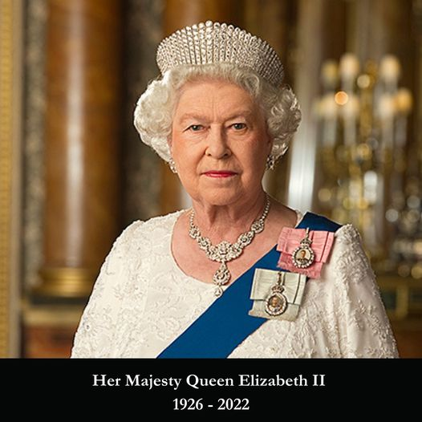
The loss of Queen Elizabeth II was felt not only in Patrington but in the rest of the United Kingdom and all over the world.
However, this sad occasion also heralds a new monarch, King Charles III.
We hope he has a long and positive reign.

A book of Condolences was opened in St Patrick’s Church and space was made at the War Memorial for floral tributes to Her Majesty.
Chair of Patrington Parish Council, Cllr Claire Holmes read out the proclamation announcing the new king to a large gathering of residents at the War Memorial which was also the scene of a one minute’s silence.

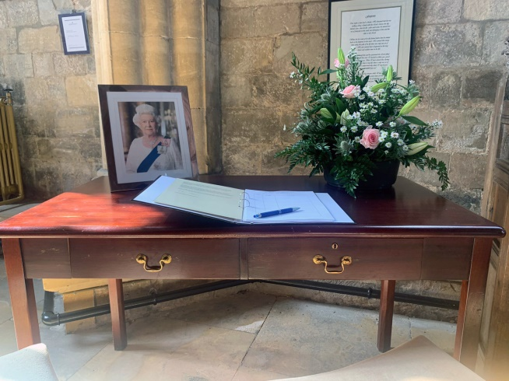 | 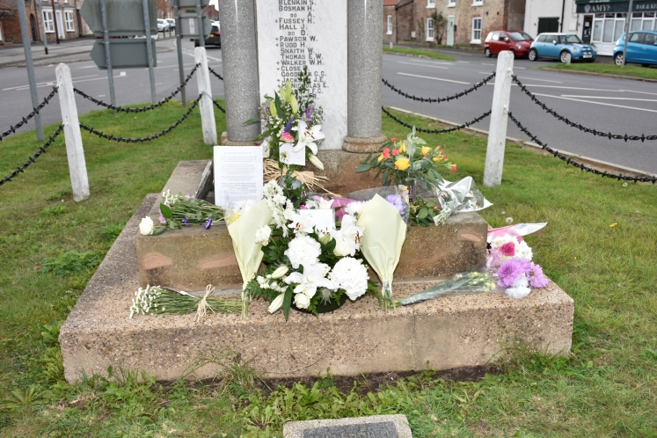

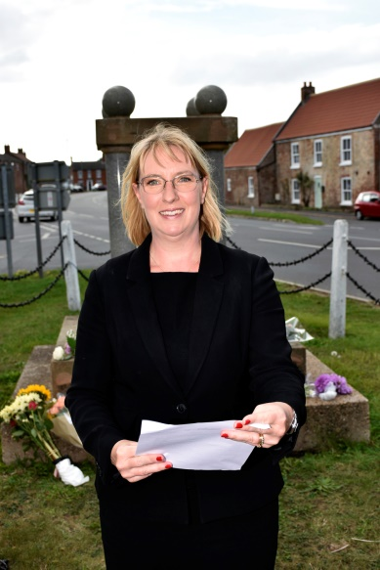 | 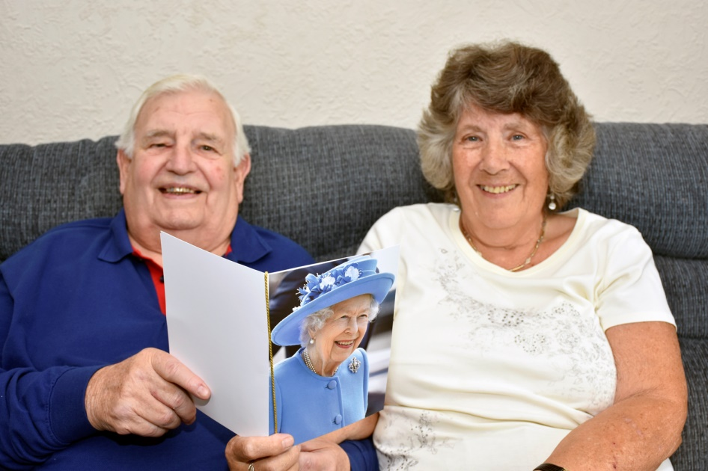

Patrington residents Terry and Jean Heap were pleased to receive one of the last cards sent out by the Queen to mark their Diamond Wedding Anniversary.
Church in Bloom

St Patrick’s Church held a very successful Flower Festival over the first weekend of the month, attracting many visitors to our wonderful church.
The theme was Sport, and this produced many marvellous displays, demonstrating skill and imagination.

Here are some photos of just a few of the displays.

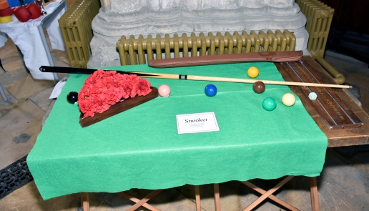 | 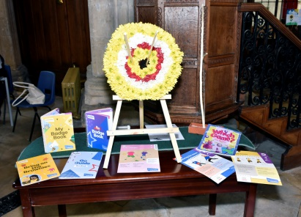 | 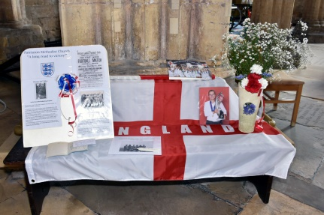
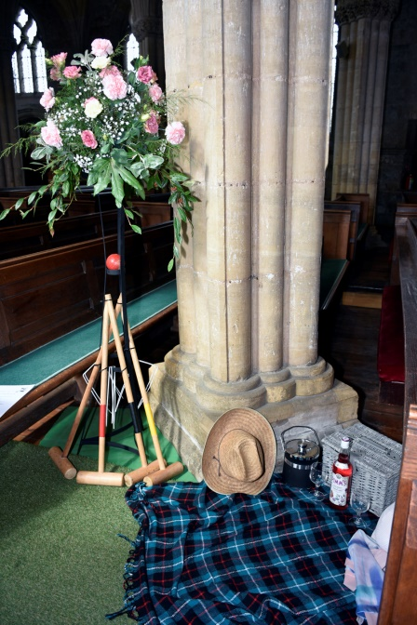 | 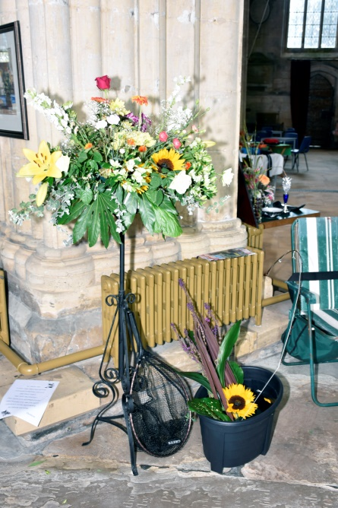 | 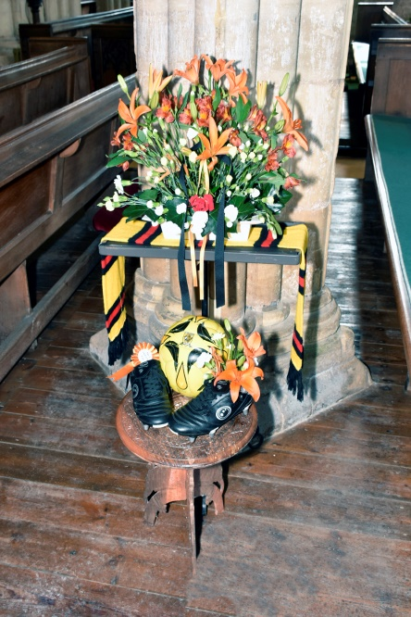
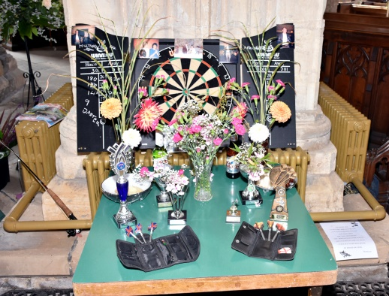 | 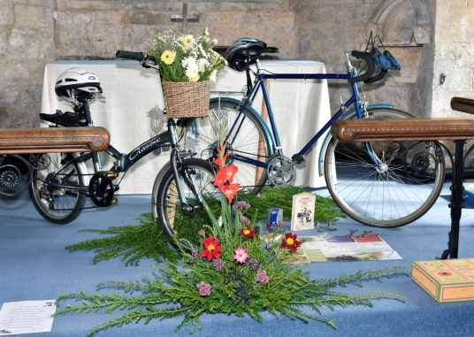 | 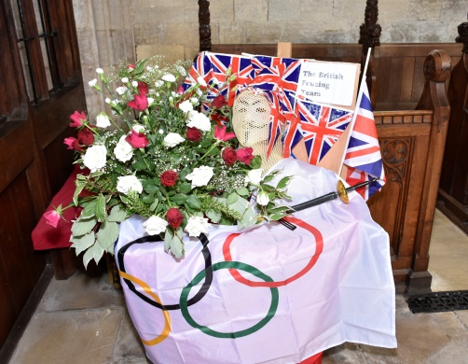
Patrington Christmas Lights switch-on will take place on the afternoon of Sunday, November 27. More details will be published nearer the day.  St Patrick’s Church news  26-27 November: Christmas Market in the Church  9 December: Christmas Party in the Church Hall  The seat in memory of Her Majesty the Queen has now been installed in the play park on Welwick Road  A commemorative plaque will soon be fitted to the seat |  | Community Groups  Mondays  Brownies  Church Rooms  Monday 6pm to 7.30pm  Tai Chi 1-2.30 [every week] Village Hall  Beavers 6-7pm [every term week] Village Hall  Parish Council 7.15pm [first Monday of each month] Village Hall  Tuesdays  Indoor Bowls  Sept to April  1.30pm to 4.30pm  Tai Chi 7-8pm [every week] Village Hall  Wednesdays  Cubs 6.30-7.30 [every term week] Village Hall  Thursdays  Bingo [every other week] 7pm Village Hall  WI [2nd Thursday of each month] Church Hall  Fridays  Patrington Play Group [every week] 9.30 – 10.30 Village Hall  Scouts 7pm – 8.30 pm Village Hall  Sundays  Table Tennis 6-8pm [every week] Village Hall  We are hoping to publish the newsletter every quarter so if you have anything you would like in it please contact the Parish Clerk, Diane Chapman, on 01964 630554 or email patringtonpc@btinternet.com

