The newsletter covering Patrington, Patrington Haven and Winestead
------------------------------------------------------------------------------------------------------

Issue 3 November 2022
-----------------------------------------------------------------------------------------------------

The Village remembers

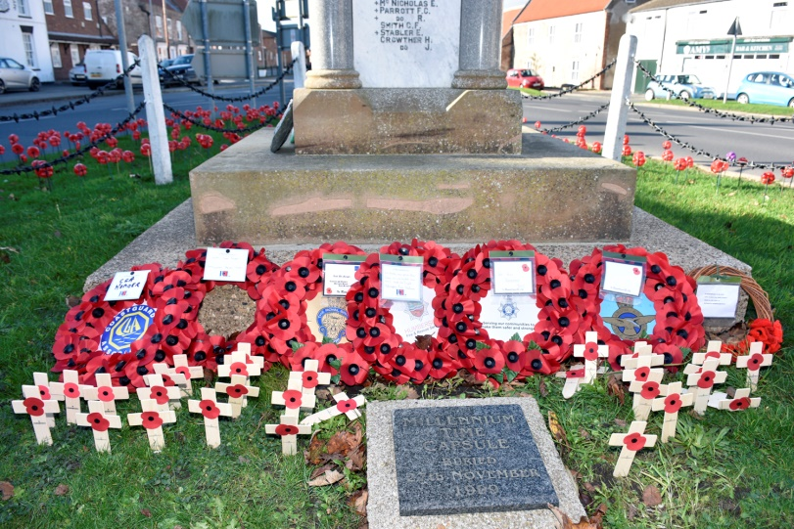
There was an excellent turn-out at the War Memorial on Friday November 11 at 11am to remember the fallen of the two World Wars and other conflicts.
A large number of wreaths were laid by organisations and individuals after the sort service led by Cllr Claire Holmes, Chair of Patrington Parish Council.
Year 6 pupils from Patrington Primary Academy also attended.

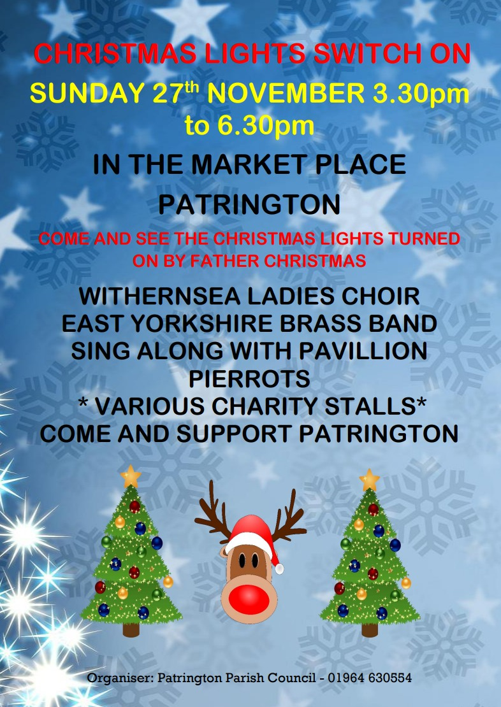

St Patrick’s Christmas Fayre

The Church will be pleased to see you on Saturday and Sunday, November 26 and 27, from 10am to 4pm.
There will be a host of stalls selling all manner of crafts and gifts, an ideal opportunity to get your Christmas gifts.
And of course the ladies will be serving refreshments, including soup, cakes and drinks.

